

VILNIUS UNIVERSITY
ŠIAULIAI ACADEMY
BACHELOR PROGRAMME SOFTWARE ENGINEERING

Computer networks laboratory work No. 5

Student : Hanna Asiadouskaya
Lecturer: dr. Nerijus Ramanauskas

Šiauliai, 2024
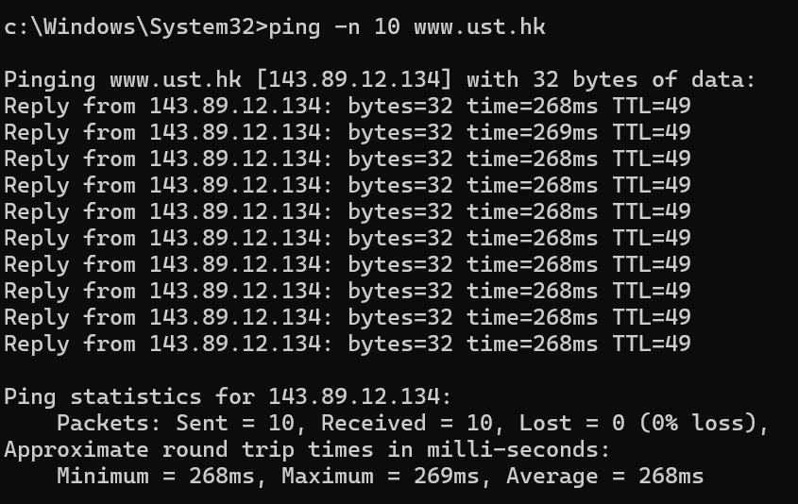
- Host ip: 192.168.0.131. Destination: 143.89.12.134
- It can’t have source and destination port numbers because as it was made to communicate network-layer information between hosts and routers, not between application layer processes.
- Type 8, Code 0, Checksum 2 bytes, Id 2 bytes, Sequence number 2 bytes
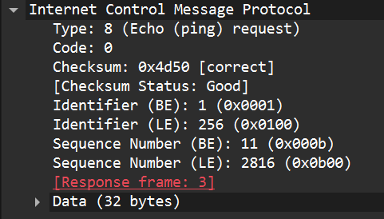
- Type 0, Code 0, Checksum 2 bytes, Id 2 bytes, Sequence number 2 bytes
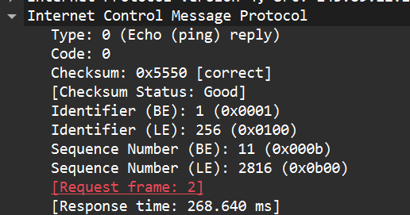

- Host ip: 192.168.0.131. Destination: 143.89.12.134
- No. If ICMP sent UDP packets instead, the IP protocol number should be 0x11
- No, it is the same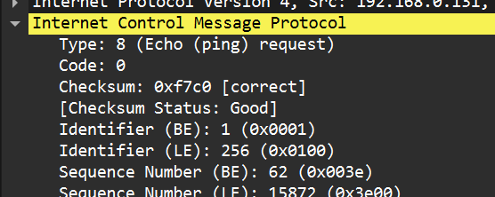
- Error packet contains both the IP header and the first 8 bytes of the original ICMP packet that the error is for.
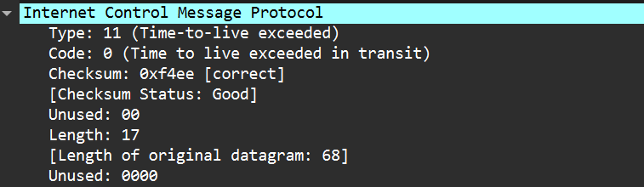
- The last ICMP message has type 0 (echo reply) rather than 11 (TTL expired), because packet made it rather than being timed out.
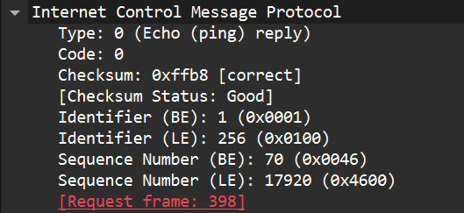
- Link between steps 10 and 12 has a longer delay. This is a link from Frankfurt, Germany to New York, USA.

